**WEEK 1: ISP API call**

* **The code allows Content provider to send customer information to the ISP to create respective parameters in the network.**
* **When the customer clicks on the Content Provider’s URL to create its own website. Content provider will push 3 parameters for the customer on the ISP side:**
  1. **Customer VLAN**
  2. **Customer ID**
  3. **IP address assigned for the customer URL**
* **This is the code for API call where Content provider can do “curl” request to the ISP with all the parameters that it wants to push on the ISP side**
* **CURL request from the terminal to POST:**



* **Output of the code:**

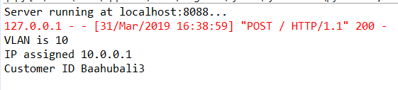

* **Respectively for every user, VLAN, IP and Customer ID can be created using a curl request from the Content Provider end.**

**APPENDIX**

* **Sample curl commands to GET, HEAD and POST**

1. **POST ==> curl -d "foo=bar&bin=go" http://localhost:8088**
2. **GET ==> curl "http://localhost:8088?foo=bar&bin=go"**
3. **HEAD ==> curl -I http://localhost:8088**